Given the head of a linked list, remove the nth node from the end of the list and return its head.

**Example 1:**

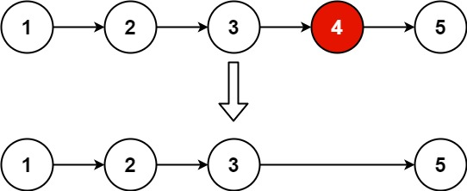

Input: head = [1,2,3,4,5], n = 2  
Output: [1,2,3,5]

**Example 2:**

Input: head = [1], n = 1  
Output: []

**Example 3:**

Input: head = [1,2], n = 1  
Output: [1]

**Constraints:**

* The number of nodes in the list is sz.
* 1 <= sz <= 30
* 0 <= Node.val <= 100
* 1 <= n <= sz

**Follow up:** Could you do this in one pass?